**NAME OF SCHOOL: ................................................................................**

**NAME OF CANDIDATE: ..........................................................................**

**INDEX NO: ..................................... SIGNATURE: ................................**

**273/1**

**GEOGRAPHY**

**PAPER 1**

**JULY/AUGUST**

**2 ½ HOURS**



**ELITE EXAMINATION BUREAU MOCK 2019**

**Uganda Certificate of Education**

**GEOGRAPHY**

**PAPER 1**

2 HOURS 30 MINUTES

**INSTRUCTIONS TO CANDIDATES:**

* *This paper consists of parts* ***I*** *and* ***II****.*
* *Part* ***I*** *and section* ***A*** *of part* ***II*** *are compulsory.*
* *Answer only* ***one*** *question from section* ***B*** *of part* ***II****.*
* *Answers to all questions must be written in the answer booklet provided.*
* *Any additional question(s) attempted will* ***not*** *be marked.*

**Turn over**

**PART I:**

**OBJECTIVE TYPE QUESTONS (30 MARKS)**

*There are* ***30*** *compulsory questions. Each question carries one mark. Answers to this part must be written in the answer booklet provided.*

1. The major problem facing densely populated areas of East Africa is

A. congestion. B. disease spread.

C. high cost of land. D. food shortage.

2. Which of the following rocks contain fossils?

A. Coral reefs. B. Obsidian.

C. Quartz. D. Gabbro.

3. Lake Longonot in Tanzania occupies a

A. graben. B. meander scar.

C. cirque . D. caldera.

4. Which of the following is the main problem limiting exploitation of tropical highland forests in East Africa?

A. Narrow market. B. Dangerous wild animals.

C. Insecurity. D. Steep slopes.

5. Which one of the following is the major factor responsible for the extension of the railway line to Northern Tanzania?

A. Mineral deposits. B. Presence of ports.

C. Presence of cities. D. Presence of agricultural produce.

6. Hanging valleys on the slopes of mountain Rwenzori are a major potential for

A. transport development. B. hydro electric power production.

C. tourism development. D. livestock rearing.

7. Which one of the following groups of minerals is non-metallic?

A. Soda ash and copper. B. Limestone and silver.

C. Phosphates and potash. D. Zinc and mica.

8. The main limitation to the development of out-growers schemes in East Africa is

A. pests and diseases . B. low level of technology.

C. land shortage. D. price fluctuation.

9. Cement factories in East Africa are located near the source of

A. market. B. power. C. raw material. D. water.

10. Which of the following weathering processes is dominant around Lake Magadi?

A. Frost shattering. B. Salt crystallization.

C. Oxidation. D. Pressure release.

11. The Mau ranges were formed as a result of

A. vulcanicity. B. faulting.

C. warping. D. folding.

12. Hale hydro electric power dam is located on river

A. Pangani. B. Tana. C. Nzoia. D. Thika.

13. Which of the following is true about Bamboo forests?

A. grow in hot areas. B. grow tall.

C. have buttress roots. D. have needle like leaves.

14. The weather condition affecting visibility in the valley areas of south western Uganda is

A. fog. B. snow. C. frost. D. dew.

15. Which one of the following wave depositional features has greatly contributed to port development in East Africa?

A. Mud flat. B. Beach. C. Ria. D. Sand bar.

16. The development of marine fishing along the Indian ocean coast is majorly limited by the presence of

A. high tides. B. strong waves.

C. fish predators. D. coral rocks.

17. The main activity at Lake Nakuru national park is

A. birding. B. nature walks.

C. hiking. D. sport fishing.

18. Which of the following features is formed on the torrent stage of a river?

A. Flood plain. B. Pot holes.

C. Delta. D. Meander.

**Turn over**

19. Which of the following is the most effective measure to control landslides in East Africa?

A. Re-afforestation. B. Terracing.

C. Agro – forestry. D. Resettlement.

20. Ports along the Kenyan coast have adopted containerization mainly to

A. reduce damage of goods. B. ease loading and unloading.

C. increase cargo handled. D. reduce congestion.

21. The tiny visible droplets of water floating in air are referred to as

A. humidity. B. atmospheric pressure.

C. wind strength. D. cloud cover.

22. Which of the following fish landing sites is located on Lake Tanganyika?

A. Muleba. B. Kasanga. C. Lyingo. D. Magyo.

23. Which of the following is the major crop grown at Galole irrigation scheme?

A. Cotton. B. Maize C. Sugarcane. D. Rice.

24. The main challenge to the conservation of wild life in East Africa is

A. poaching. B. bush fires.

C. low and unreliable rainfall. D. increase in population.

25. Which one of the following tree species grows naturally in low latitude areas of East Africa?

A. Fir. B. Cypress. C. Ebony. D. Beech.

26. Which of the following processes was associated with river reversal in East Africa?

A. Glaciation. B. Wave erosion.

C. Warping. D. Tectonism.

27. Soil erosion in the dry areas of East Africa is greatly a result of

A. unreliable rainfall. B. over stocking.

C. low water table. D. very hot temperatures.

28. The underdevelopment of ranching in East Africa is mainly due to

A. high taxes. B. unreliable power supply.

C. limited extension services. D. inadequate capital.

29. Which one of the following types of transport is mostly used for the delivery of bulky commodities in East Africa?

A. Rail. B. Air. C. Road. D. Water.

30. East African governments are emphasizing the development of small – scale industries mainly to

A. reduce rural – urban migration.

B. generate employment opportunities.

C. develop skills of the local people.

D. increase foreign exchange.

**PART II**

**MAP WORK, PHOTOGRAPH INTERPRETATION, FIELD WORK AND EAST AFRICA**

*Answer* ***four*** *questions from part* ***II****, including question* ***1****,* ***2*** *and* ***3*** *which are compulsory.*

**SECTION A**

1. **COMPULSORY QUESTION: MAP WORK (20 MARKS)**

Answer **all** parts of this question.

Study the **EAST** **AFRICA** **1:50**,**000** **(UGANDA) ALOI** Map extract, part of sheet 33/1, series Y732, Edition 1 – U.S.D and answer the questions that follow.

a) i) State the grid reference of the bore hole North of Omito. (1 mark)

ii) Name the relief feature found at grid reference 248588. (1 mark)

b) Calculate the area covered by the county in the west. (3 marks)

c) Draw a cross – section of the area shown between grid references 210500 and 277555 and on it mark and name:

i) settlements,

ii) river,

iii) all weather loose – surface road,

iv) hill top,

v) footpath. (8 marks)

d) Giving specific examples from the map extract

i) identify any two settlement patterns shown on the map.

(2 marks)

ii) Problems facing settlement in the area shown on the map.

(5 marks)

**Turn over**

**2 .COMPULSORY PHOTOGRAPH INTERPRETATION QUESTION (15 MARKS)**

*Answer* ***all*** *parts of this question*

Study the photograph provided below and answer the questions that follow.

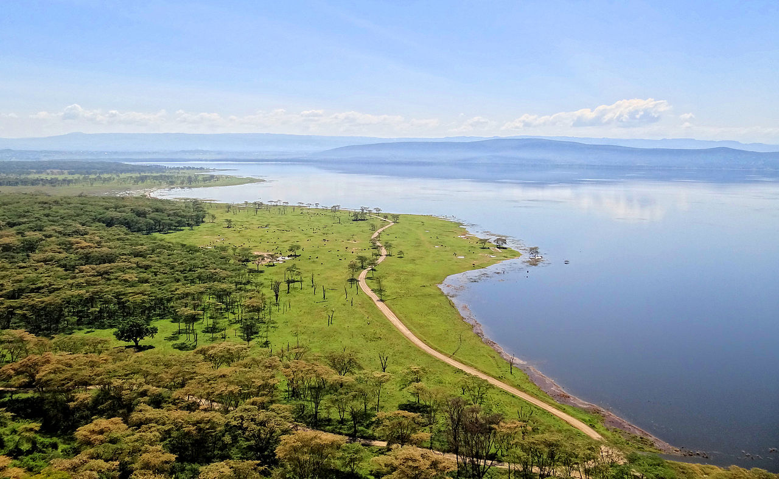

a) Giving reasons for your answer, state the type of photograph provided above. (1 mark)

b) Using a tracing paper, draw a landscape sketch of the area shown on the photograph and on it, mark and label:

i) a water body,

ii) a transport route,

iii) any two relief features,

iv) forest vegetation. (7 marks)

c) Describe the processes leading to the formation of the relief feature in the central middle ground of the photograph. (5 marks)

d) Giving reasons for your answer, suggest an area in East Africa where this photograph could have been taken. (2 marks)

**3. COMPULSORY FIELD WORK QUESTION (15 MARKS)**

*Answer* ***all*** *parts of this question.*

For any **one** field work study you have conducted:

a) i) State the topic of study. (2 marks)

ii) Outline the objectives of the study. (2 marks)

b) Draw a sketch map of the area studied and on it mark and name;

i) physical features

ii) land use activities. (5 marks)

c) Describe the relationship between physical features and land use in the area studied. (4 marks)

d) Outline the geographical skills you gained during the study. (2 marks)

**SECTION B: EAST AFRICA (20 MARKS)**

Answer only **one** question from this section.

4. a) Draw a sketch map of East Africa and on it, mark and name:

i) Water falls: Murchison and Grand,

ii) Rivers: Pangani and Nzoia

iii) The western arm of the rift valley. (6 marks)

b) Describe the conditions which have led to the formation of water falls in East Africa. (4 marks)

c) Explain the benefits of waterfalls to the countries of East Africa.

(6 marks)

**Turn over**

d) Outline the problems experienced by people living around water falls in East Africa. (4 marks)

5. a) Differentiate between Absolute humidity and Relative humidity.

(4 marks)

b) Describe how humidity is measured at a weather station. (6 marks)

c) Explain the factors which influence humidity in East Africa. (6 marks)

d) Outline the problems faced by people living in areas of high humidity in East Africa. (4 marks)

6. Study the table below showing Tanzania’s Diamond total exports to selected countries (2007) and answer the questions that follow.

|  |  |
| --- | --- |
| Country | Diamond exports in million US $ |
| Israel  Belgium  India  United Kingdom  Botswana  South Africa | 18,411  48,273  13,363  8,490  3,172  2,488 |

Adopted: Tanzania’s Mining sector and its importance for the Country’s Development Working Paper No. 04/2011, Petro S Magai and Alejandro Marquez – Velazquez, August 2011, Pg4.

a) Calculate the total contribution of selected countries from

i) Africa, (2 marks)

ii) Asia and (2 marks)

iii) Europe (2 marks)

to the value of Tanzania’s Diamond exports.

b) Draw a pie – chart to show the contribution by continents identified in (a) above to Tanzania’s Diamond total exports. (4 marks)

c) Explain the problems limiting the exportation of diamonds in Tanzania.

(6 marks)

d) Outline the steps being taken to increase diamond exports in Tanzania.

(4 marks)

7. Study figure **1**, map of Mwea – Tebere irrigation scheme and answer the questions that follow:

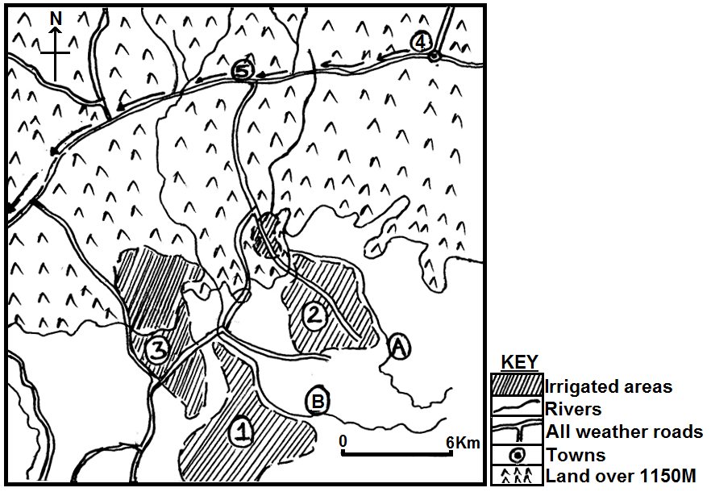



a) Name the:

i) irrigated blocks marked **1**, **2** and **3**,

ii) town marked **4**,

iii) all weather road marked **5**,

iv) rivers marked **A** and **B**. (7 marks)

b) Describe the physical conditions which favoured the establishment of the Mwea – Tebere irrigation scheme. (5 marks)

c) Explain the importance of the Mwea – Tebere irrigation scheme to the people working in the area. (6 marks)

d) Outline the problems hindering farming activities on the irrigated area.

(2 marks)

**END**